Introduction of a comprehensive phantom for the quality control of contrast enhanced spectral mammography
ControlNr.: | #7473
Keywords: | Breast, Radiation physics, Contrast agents, Mammography, Digital radiography, Equipment, Contrast agent-intravenous, Quality assurance, Kv imaging
Status: | IN WORK
Type: | Scientific Exhibit
Authors: | R. Klausz, M. Rouxel, X. Mancardi, A.-K. Carton, F. Jeunehomme Patoureaux; BUC/FR

Aims and objectives
Contrast enhanced digital mammography (CEDM), is gaining more and more adoption considering the benefits it provides in detecting and differentiating breast lesions [1,2]. Currently four commercial products featuring CEDM are proposed, all based on energy subtraction, or spectral mammography (CESM). However, not all mammography specialists are comfortable with injecting patients, and they must be sure that the equipment will perform as expected, i.e. demonstrate reliably the presence or absence of iodine in tissues. Both are equally important, showing that a suspicious area seen in the regular mammogram is probably non-cancerous, or revealing possibly cancerous lesions by a contrast uptake. Even if regular maintenance and quality control ensure a safe operation of the equipment, it may not give a full certitude that the next examination will satisfy all performance criteria. For this reason, an improved phantom has been designed, as close as possible to a real breast, and containing iodinated and non-iodinated contrast objects. A quick imaging sequence of this object will demonstrate nominal operation and give users full confidence before starting the examination. The specification of this phantom will be described here, as well as the test results of a prototype made according to it.

Section: Methods and materials
To ensure a good cancellation of the image of non-iodinated breast tissues, the composition of the background material of the phantom must be as close as possible to the actual breast tissues. It must also represent as well as possible the range of breast densities from adipose to glandular. Consequently breast-equivalent materials have been chosen as the only constituents of the different elements of this phantom.
Core Plate description:
In previously described solutions, the plate containing the iodinated inserts was made of PMMA [4,5]. Here it is constituted of material equivalent to 50% adipose 50% glandular tissues, such as BR5050 (CIRS Inc, Norfolk, VA, USA). Two sets of four cylinders, 10 mm in diameter, made of the same base material to which an iodinated component is added, are plugged into this plate with their centres positioned along two 25 mm symmetrical squares. The iodine concentrations have been chosen to cover the clinical range of areal densities of 0,25, 0,5, 1 and 2 mg/cm². A fifth insert made of 100% glandular tissue equivalent material (BR100) is positioned in the centre of each square to mimic a glandular lesion. The plate and the inserts are all 10 mm high. The overall lay-out of the plate has been arranged to match the shape and mounting of the existing CIRS Digital Breast Tomosynthesis QC Phantom (figure 1).

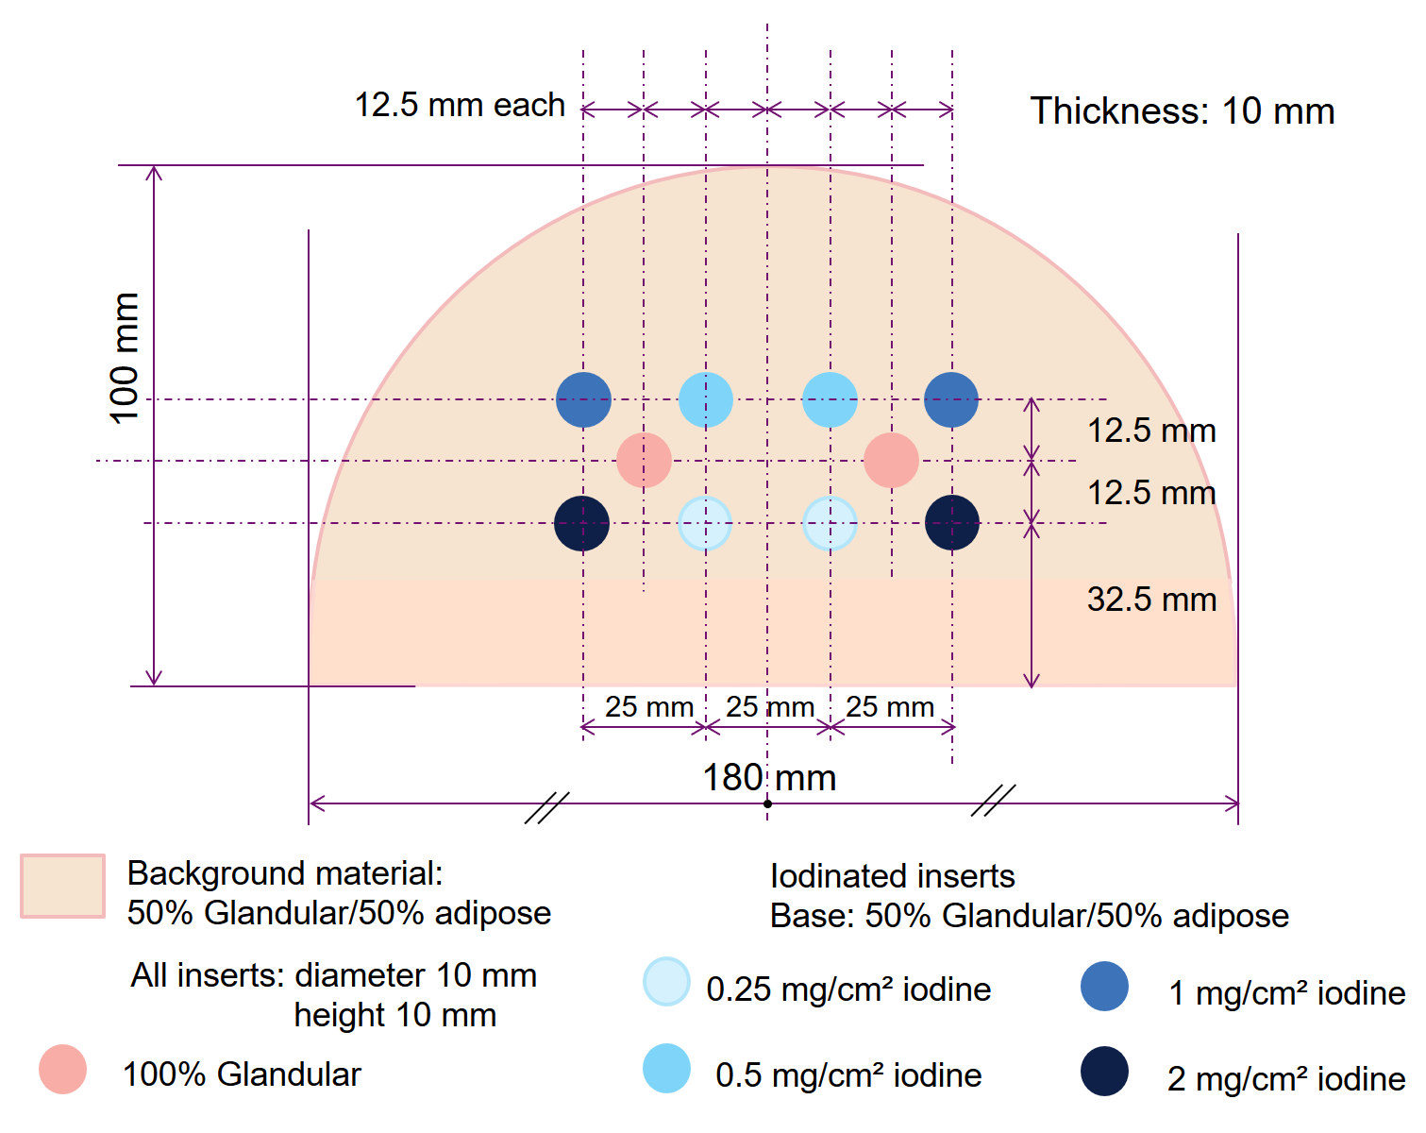
The 100% glandular inserts should be much more visible than 2 mg/cm² iodine in regular mammograms, and disappear after recombination. The two sets of iodinated inserts are disposed symmetrically to be strictly identical from all points of view, including heel-effect, scatter, or various non-uniformities; they will be superimposed with different background densities to check possible dependence of iodine contrast.
Background plates:
The total phantom (core plate plus background) should be representative of an average breast.
A total thickness of 55 mm is retained as corresponding to the observed average compressed breast thickness in western population [6]. The top and bottom plates are 10 mm thick, with rounded edges. They are made of adipose tissue equivalent material (BR0) to mimic subcutaneous fat. The remaining thickness (55 – 2x10 - 10) = 25 mm is made in two halves respectively equivalent to adipose (BR0 material) and glandular tissue (BR100 material) to test the dependence of iodine separation from background over a large range of densities. In the sense of Dance (2000) [7] the average breast compositions of the two halves of the total phantom are respectively 11 % and 67 %, to be compared with the reference value of 25% and 40% for ages ranges 40-49 and 50-64 respectively (interpolated from [7]). This demonstrates a reasonable balance, and takes provision for significant composition non-uniformities inside a breast (figure 2).
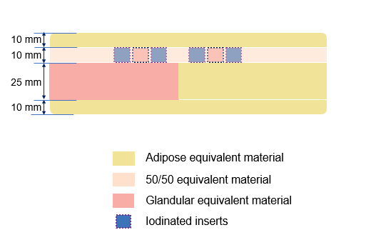
Fig. 2 : Front view of the compete phantom, core plate and background plates
In this particular instantiation of the phantom the different plates are maintained together through the “Positioning Holder with Magnetic Fixation” of the DBT phantom. Obviously different concepts could be used the same way.
Phantom imaging
A prototype of the phantom has been built by CIRS Inc. It has been imaged using SenoBright HD, the CESM option for Senographe PristinaTM (GE Healthcare, Chicago, IL, USA), and the images viewed and measured.
The criteria to meet on recombined CESM images are:
- Elimination of contrasts between the adipose and glandular equivalent materials
- Visibility of the iodinated inserts
- Insensitivity of the iodine contrast to the background material
- Good relation between iodine concentration and contrast in images
All these criteria can be quickly checked visually, making it a simple and effective test of good operation.
In addition, quantitative assessment of the same criteria can be done. On this equipment, by design, the image levels in recombined images should be 2000 in absence of iodine, whatever the background, and the difference to 2000 proportional to iodine areal concentration.
Measurements have been performed on the recombined images “for display”, in circular regions of interest (ROI), 5 mm in diameter, centred on the inserts and positioned around them (top, bottom, left, right), equidistant from the inserts. For each insert the background value retained has been the average of the mean values (B1 to B4) of the four surrounding ROIs (figure 3). The values of the different backgrounds have been compared to each other and to the reference value 2000.
The contrasts generated by the inserts have been computed as the signal differences between the mean values in the ROIs centred on the inserts (I) and the corresponding backgrounds.
The operation has been done for each iodinated insert and the glandular insert on both the adipose and the glandular background

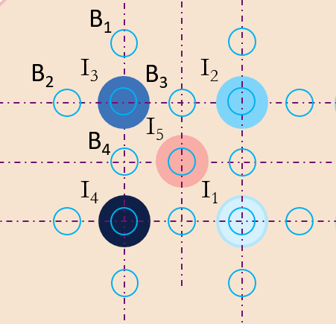
Fig. 3 : Positions of the ROIs for quantitative assessment. B: ROIs for measuring the background values; I1 to I4 the ROIs for measuring the iodinated inserts from 0.25 to 2 mg/cm²; I5 the ROI for the measurement of the glandular insert

Results
Visual Inspection of the phantom:
The appearance of the different phantom plates is according to expectation (figures 4 and 5).
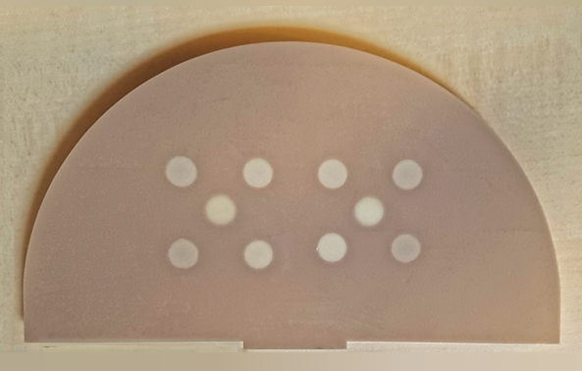
Fig. 4 Actual core plate with glandular and iodinated inserts
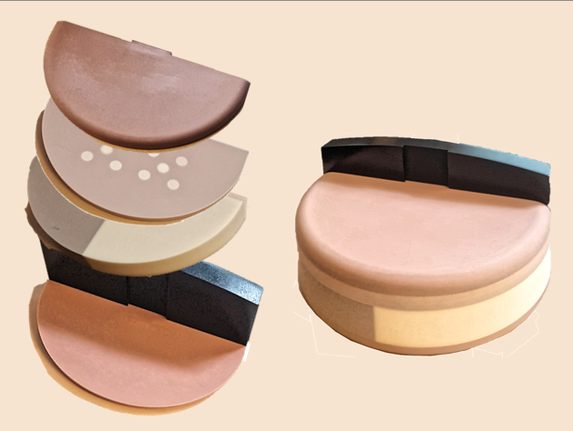
Fig 5: set of plates and complete assembled phantom
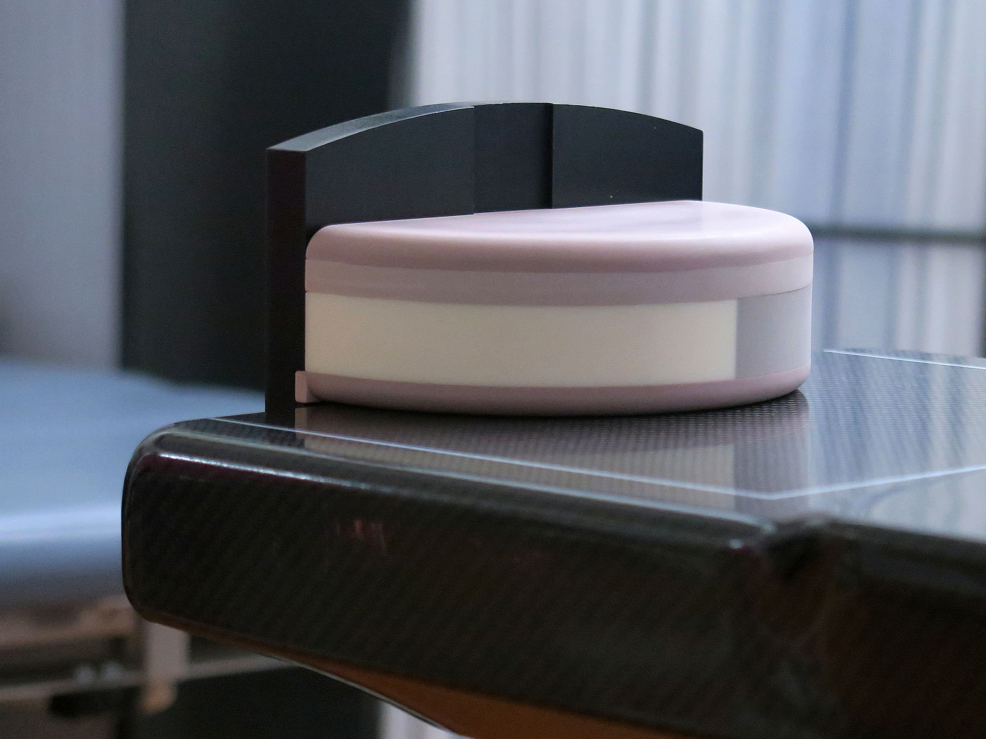
Fig 6: Phantom positioned on the mammographic equipment
Visual observation of images:
After CESM acquisition (figure 6), the low energy image (same as a regular mammogram) mostly shows the very large difference between the two halves, making it difficult to display in a single image. Using different contrast window settings for each half allows to better demonstrate the different contrasts, and in particular the good visibility of the glandular inserts and the weak contrast of the iodine inserts (figure 7).
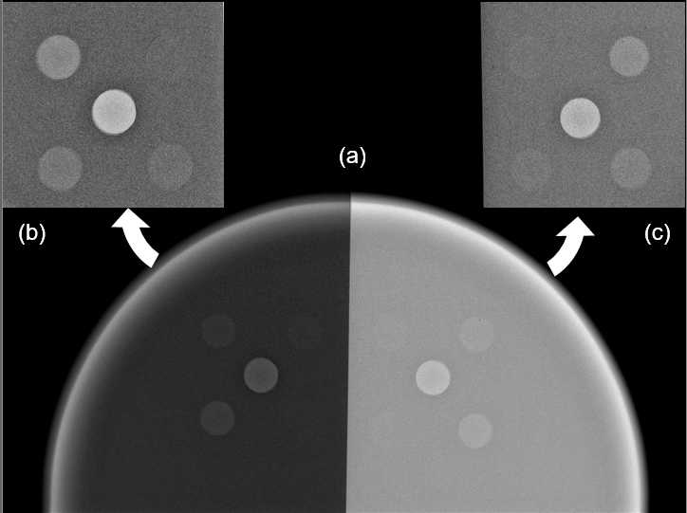
Fig.7: Regular mammogram of the complete phantom (Low energy component of the CESM pair)
a) complete phantom; b) and c) details of adipose and glandular halves with adjusted window settings
After CESM processing between the low and high energy images, all iodinated inserts are visible with the same contrast windowing, over both glandular and adipose backgrounds. The difference between the two halves of the phantom (adipose vs. glandular) is hardly visible, and the 100% glandular inserts cannot be seen anymore (figure 8)
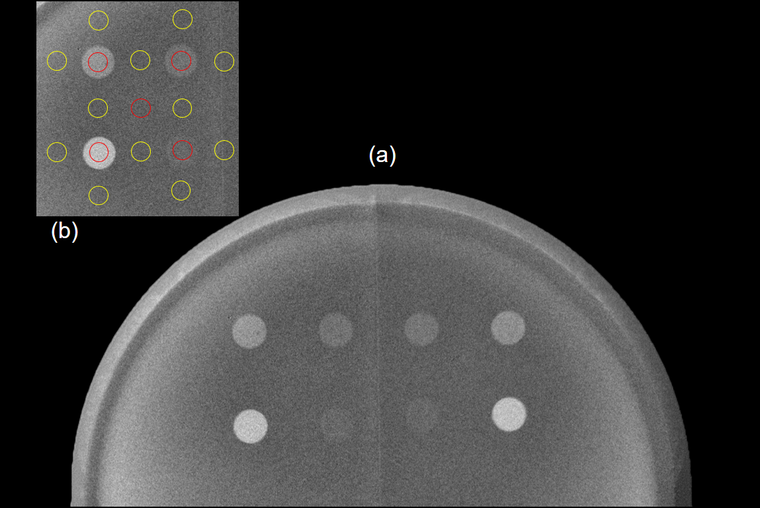
Fig.8: Recombined CESM image - a) complete phantom; b) positions of the ROIs for measuring the image levels in the inserts (red) and the surrounding background (yellow). The same applies on both sides.

Measurements results (table 1):
Table 1: results of measurements
 | Adipose Background |  |  |  | Glandular Background
Insert type | Background |  | Insert | Signal Difference | Background |  | Insert | Signal Difference
(mg/cm²) | Mean | STD |  |  | Mean | STD
0.25 | 1998.6 | 10.3 | 2004.3 | 5.7 | 1999.6 | 11.5 | 2005.0 | 5.4
0.5 | 1998.0 | 10.4 | 2015.1 | 17.2 | 1998.1 | 11.6 | 2013.2 | 15.1
1 | 2000.3 | 10.5 | 2031.3 | 31.0 | 2006.1 | 11.6 | 2038.3 | 32.2
2 | 1998.5 | 10.2 | 2069.5 | 70.9 | 2000.8 | 11.6 | 2068.9 | 68.1
Gland | 1999.2 | 10.3 | 2000.2 | 1.0 | 1999.3 | 11.6 | 1999.7 | 0.4

- The different background levels are not significantly different from the nominal value of 2000, whatever the background
- The differences between the different backgrounds are not significantly different between the glandular half and the adipose half
- The differences between image levels in the glandular inserts are not significantly different from their respective backgrounds in both halves
- The signal differences in the most diluted iodinated inserts (0.25 cm²/g) are about one-half standard deviation; all other concentrations are 1.5 to 7 times the standard deviation
- For a given concentration, the signal differences in iodinated inserts are not significantly different between the two halves
- The signal differences between the iodinated inserts and the background are linear with the nominal iodine concentrations (R² > 0.999) (figure 9). The linear relations between signal differences and iodine concentrations are not significantly different over adipose or glandular backgrounds

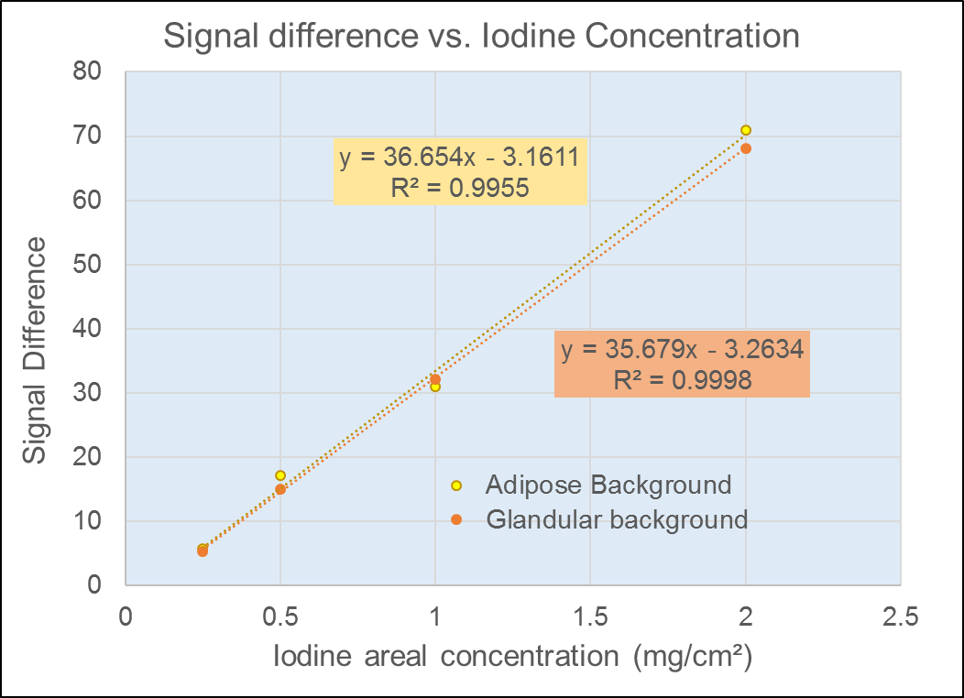
Fig. 9: Variation of signal differences with iodine concentration on the two halves of the phantom
Conclusion

The goal for this work was to define a simple comprehensive phantom for CESM containing both clinical iodine concentrations and important breast density differences. Performing CESM images of this phantom periodically or even before each session should demonstrate to users the nominal operation of the equipment.
A design has been proposed, a prototype was built according to specifications, and the CESM images obtained from it demonstrate the expected results. Further quantitative analysis confirmed the visual assessment and could be used for constancy testing.
Section: Personal information
All authors are employees of GE Healthcare
Global Women's Health Engineering
283 rue de la Miniere
78530 Buc (FR)
Rémy Klausz remy.klausz@ge.com
Marion Rouxel marion.rouxel@ge.com
Xavier Mancardi, PhD xavier.mancardi@ge.com
Ann-Katherine Carton, PhD ann-katherine.carton@ge.com
Fanny Patoureaux, PhD fanny.patoureaux@ge.com

References

[1] Roberta A. Jong, MD, Martin J. Yaffe, PhD, et al.
Contrast-enhanced Digital Mammography: Initial Clinical Experience
Radiology (2003); 228:842–850
[2] Clarisse Dromain, Fabienne Thibault, Serge Muller et al.
Dual-energy contrast-enhanced digital mammography : initial clinical results
Eur Radiol (2011) 21:565–574
[3] Oduko J., Homolka P., Jones V., Whitwam D. (2014)
A Protocol for Quality Control Testing for Contrast-Enhanced Dual Energy Mammography Systems. In: Fujita H., Hara T., Muramatsu C. (eds) Breast Imaging. IWDM 2014. Lecture Notes in Computer Science, vol 8539. Springer, Cham
[4] Yana Popova, Remy Klausz, Henri Souchay et al.
New phantom concept for double-energy contrast-enhanced digital mammography
Oral presentation SS1713 ECR (2010)
[5] Leithner, R., Knogler, T., Homolka, P.
Development and Production of a Prototype Iodine Contrast Phantom for CEDEM
Phys. Med. Biol.58, N25-N35 (2013)
[6] N. Geeraert, R. Klausz, D. Sundermann, S. Muller, H. Bosmans
Breast size and exposure control sensing area position: a large sample study
ECR 2012 Poster No.: C-1159 , DOI: 10.1594/ecr2012/C-1159
[7] D R Dance, C L Skinner, K C Young, J R Beckett and C J Kotre
Additional factors for the estimation of mean glandular breast dose using the UK mammography dosimetry protocol
Phys. Med. Biol. 45 (2000) 3225–3240

