Use of executable DCM files import for Motion Control.
- Download and unzip MotionControl_DCM_import.zip. Navigate to the location where the “MotionControl_DCM_import.exe” is located and double click it or click Open from right mouse button click menu.
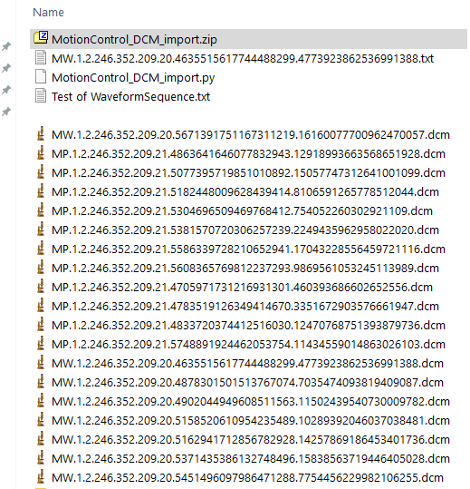

- A complete loading of the script is done when the “tk” and “Open Waveform” appears on the screen. Be patient until the script is loaded.
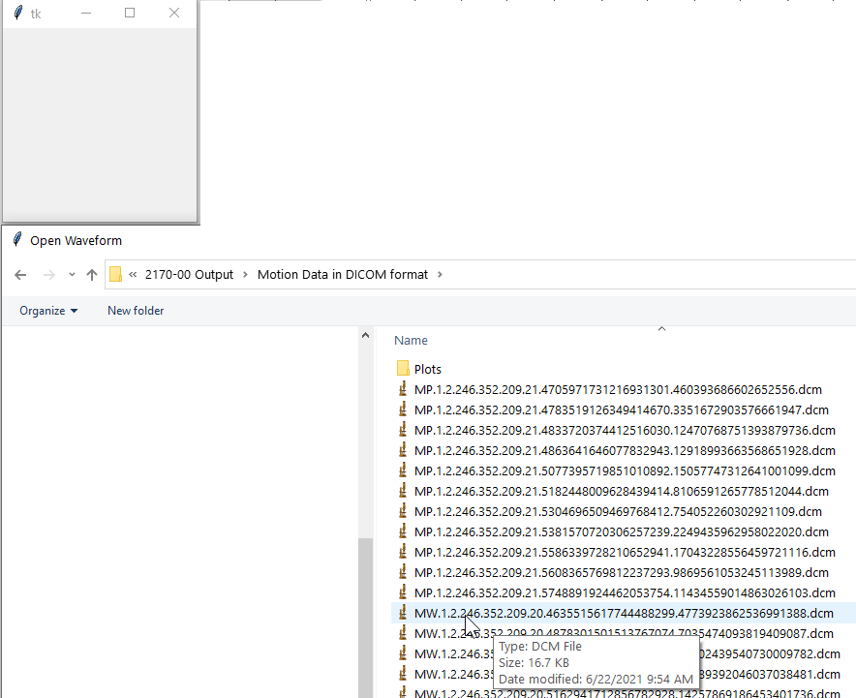

- In the “Open Waveform” navigate to the location where the DCM files are stored and select the MW DCM files you want to open to convert their motion data into a format seen by the default settings of the Import Function of Motion Control software. You can select only one file or multiple files. The multiple files can be selected in the successive order or a random order. Use the customary Shift and/or Crtl + left click to achieve these selections.
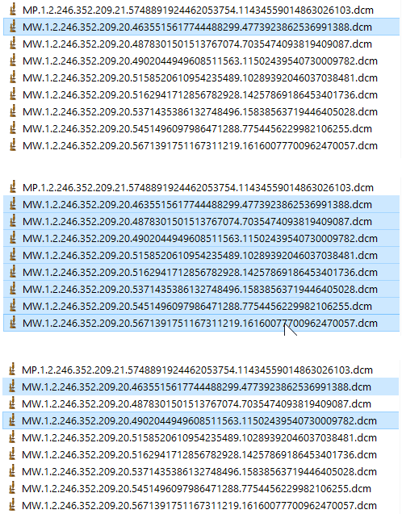
- Once the selection of the motion data files (MW… .DCM files) is made a plot of the Left-Right, Ant.-Post. and Head-Feet motion is displayed (see below). See Python documentation for ways to adjust the settings of the plot.
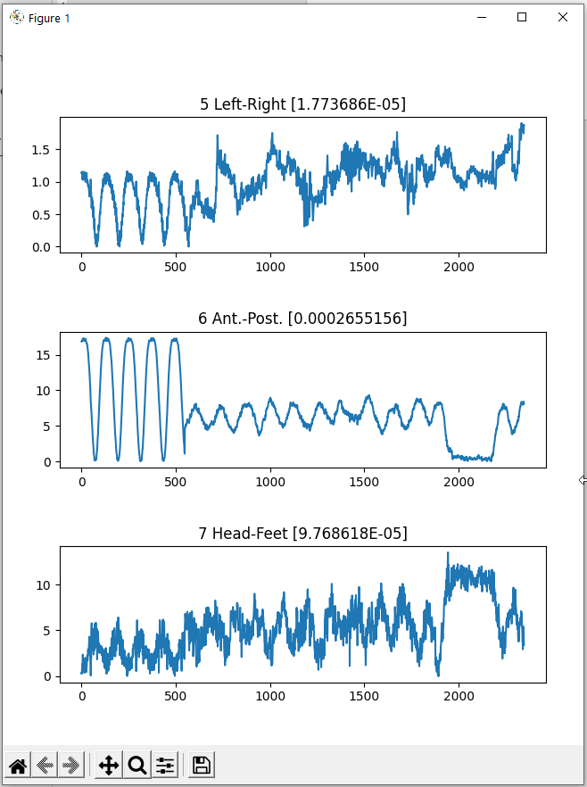
- The motion data from the “.DCM” file/files that was/were selected in step #3 is saved as a “.txt” file in the very same folder where the “.DCM” file/files is/are located. This newly created “.txt” file contains the motion data in a format that can be imported directly in Motion Control software (see below).
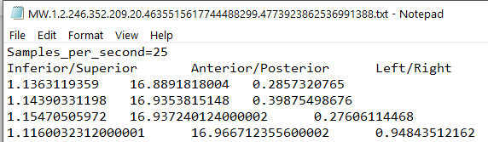
As mentioned in step #3 one single file or multiple ones can be selected for conversion. When multiple files are selected, they can be selected in a successive order or randomly. Regardless of the order of selection of the “. DCM” files the converted “.txt” is always saved with the name of the first selected “.DCM” file (see again below).

